Intelligent Semi-automated Serious Educational Game Generation for the SimSYS Serious Educational Game Development Platform

TR xxxxx

author list

Acknowledgements

xxx.

Abstract

yyy.

Table of Contents

Acknowledgements ii
Abstract iii
1. Introduction 6
2. Comparison Criteria 7
2.1 Validation 7
2.2 Assessment 8
2.3 Customization 8
2.4 Automation 8
2.5 Content Generation 8
3. A Survey on the Work Done before 8
In this section, first we discuss about Automation for non e-learning systems like Template-Based systems. In next part different approach in educational games will be explained. In third part Game Development in Education Automatic and Semiautomatic Methodologies will be challenged. Finally in the last part of this section, Automation in E-learning System will be discussed. 8
3.1 Code Generation 8
3.1.1 Automated Template-Based Metadata Extraction Architecture 8
3.1.1.1 Introduction 8
3.1.1.2 Architecture and Implementation 8
3.1.1.3 Comparison Criteria 10
• Validation 11
• Assessment 11
• Customization 11
As mentioned before, no accessibility was used to minimize the cost and effort needed for student with physical problems. 11
• Automation 11
3.2 Automation in e-learning, games, serious educational games 11
3.2.1 Different Instructional Approaches Adopted in Educational Games 11
3.2.1.1 Introduction 11
3.2.1.2 Results and Discussion in Approaches 12
3.2.1.3 Summarized Results 13
3.2.1.4 Comparison Criteria 13
• Validation 13
No validation module has been implemented in this approach. 13
• Assessment 13
• Customization 13
As mentioned before, no accessibility was used to minimize the cost and effort needed for student with physical problems. 13
• Automation 14
3.2.2 Game Development in Education Automatic and Semiautomatic Methodologies 14
3.2.2.1 Introduction 14
In this paper we discuss the need for tools that assist educators and educational content providers in producing games that are equally accessible for all. The goal is to minimize the cost and effort needed for introducing accessibility in serious games. We discuss to what extent the process of making a serious game accessible can be automated and supported by software tools that minimize human intervention. We conclude that there is a set of common accessibility barriers, especially those related to interaction and physical disabilities that can be addressed systematically in a high proportion and therefore could be dealt with by software. 14
3.2.2.2 Fully Automatic Adaptation of Interfaces - The case of 1492 14
3.2.2.3 Semiautomatic Adaptation - The case of "My first day at work" 15
3.2.2.4 Level of automatic and semi-automatic adaptation 15
3.2.2.5 Comparison Criteria 16
• Validation 16
• Assessment 16
• Customization 16
The goal is to minimize the cost and effort needed for introducing accessibility in serious games. In accessibility architecture. Accessibility was provided by specific input/output modules integrated with the engine, which are activated when the game was exported [3]. 16
• Automation 16
3.2.3 Automating e-Learning: The Higher Education Revolution 17
3.2.3.1 Introduction 17
5th Generation Distance Education: The Emerging e-University 17
3.2.3.2 Learner Relationship Management 17
3.2.3.3 Automating e-Learning 17
3.2.3.4 Comparison Criteria 19
• Validation 19
No validation module has been implemented in this approach. 19
• Assessment 19
• Customization 19
As mentioned before, no accessibility was used to minimize the cost and effort needed for student with physical problems. 19
• Automation 19
3.2.4 An Offline Planning Approach to Game Plotline Adaptation 19
3.2.4.1 Introduction 19
3.2.4.2 The Architecture of the Proposed System 20
3.2.4.3 Adaptation Algorithm 1
3.2.4.4 Comparison Criteria 3
• Validation 3
No validation module has been implemented in this approach. 3
• Assessment 3
• Customization 3
• Automation 3
3.3 Table of Comparison Criteria 3
Validation 3
Assessment 3
Customization 3
Automation 3
An Offline Planning Approach to Game Plotline Adaptation 4
4. Conclusions and Future Work 5
4.1 subheading 5
4.1.1 subheading 5
4.1.2 subheading 5
4.2 subheading 5
4.2.1 subheading 5
4.2.2 subheading 5
5. References 6
Appendix A. title here 9

Introduction

// a place to start is one paragraph for each of these:

Intro. to changing educational needs, how e-learning fits into that shift (include definition with reference for e-learning)
Intro. to serious educational games (include definition with reference of serious educational game)
Intro. to automation in serious education games (what other researchers have automated)
Intro. to the SimSYS Game Development Platform (overview, with references)
Focus in on the intelligent semi-automated game generation component
Why is this research needed?
Brief overview of the component, research methodology (including validation), and results
Structure of this report

Comparison Criteria

Validation
Validation checks that the product design satisfies or fits the intended use (high-level checking), i.e., the software meets the user requirements. This is done through dynamic testing and other forms of review. According to the Capability Maturity Model Validation is the process of evaluating software during or at the end of the development process to determine whether it satisfies specified requirements.
In other words, validation ensures that the product actually meets the user's needs, and that the specifications were correct in the first place, while verification is ensuring that the product has been built according to the requirements and design specifications. Validation ensures that "you built the right thing". IEEE

Assessment
How are serious educational games assessed?
Lab setting
Classroom setting
On-line setting

Educational/learning objectives, player satisfaction
Pre/post game assessment with exams?
Questionnaires?
Surveys?

Customization
Walt Scacchi has a nice paper on this from ICSE GAS Workshop 2011 – could use his organization of different kinds of modding

How are serious educational games customized or tailored?
Game engineer modding
Program/code modifications

End user/player modding
What can be modded?
Configuration
Scripting

Automation
Automated Verification System: A software tool that accepts as input a computer program and a representation of its specification and produces, possibly with human help, a proof or disproof of the correctness of the program. Any software tool that automates part or all of the verification process. IEEE

Content Generation

A Survey on the Work Done before

In this section, first we discuss about Automation for non e-learning systems like Template-Based systems. In next part different approach in educational games will be explained. In third part Game Development in Education Automatic and Semiautomatic Methodologies will be challenged. Finally in the last part of this section, Automation in E-learning System will be discussed.

Code Generation

Automated Template-Based Metadata Extraction Architecture

Introduction
A number of federal agencies, universities, laboratories, and companies are placing their collections online and making them searchable via metadata fields such as author, title, and publishing organization. This section describes the efforts to develop a toolset and process for automated metadata extraction from large, diverse, and evolving document collections.
Manually creating metadata for a large collection is an extremely time-consuming task, but is difficult to automate, particularly for collections consisting of documents with diverse layout and structure. The suggested automated process enables many more documents to be available online than would otherwise have been possible due to time and cost constraints. In this part the effectiveness of the tool-set by providing experimental results on two major collections DTIC (Defense Technical Information Center) and NASA (National Aeronautics and Space Administration) are illustrated [1].

Architecture and Implementation
Overview of Architecture
The proposed template-based meta data extraction system is composed of commercial and public domain software in addition to components developed by a team. Figure 1 shows the complete process. Documents are input into the system in the form of PDF files, which may contain either text PDF or scanned images. Some documents may contain a Report Document Page (RDP), one of several standardized forms that is inserted into the document when the document is added to the collection. For the DTIC collection, more than 50% of the documents contain RDPs offering more than 20 metadata fields.

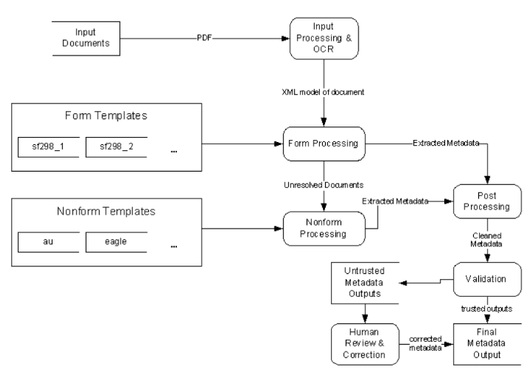
Fig. 1. Metadata Extraction Flow Diagram[1]

The documents enter the input processing system where they are truncated, processed by an Optical Character Recognition (OCR) program and converted to a standardized XML format. The first extraction step is to search for and recognize any RDP forms present. Any documents without recognized forms enter the non-form extraction process. The non-form extraction process generates a candidate extraction solution from the templates available. After extraction, the metadata from both form and non-form processing enter the output processor. The output processor is comprised of two components: a post-processing module and a validation module. The postprocessing module handles cleanup and normalization of the metadata.
The final automated step of the process is the validation module which, using an array of deterministic and statistical tests, determines the acceptability of the extracted metadata.
Any document that fails to meet the validation criteria is flagged for human review and correction [1].

Implementation
Input Processing. The source documents come into the system as PDF format files. These documents range from several pages to hundreds of pages in length. The metadata which are interested in can typically be found in the first or last five pages of a document.

Form Processing. The regular layout present in an RDP form makes it an attractive target for a template-based extraction process. In order to take advantage of the geometric relationships between fields in a form, an alternate version of related template language and extraction engine is created. The metadata fields are specified by a matching string and a set of rules indicating a positional relationship to one or more other fields.

Non-form Processing. As shown in Figure 1, documents without an RDP form enter the non-form processor. The documents are first transformed from IDM into another XML format called CleanML, which encodes the paragraphs and lines and their corresponding features (font size, style and alignment) into an XML structure. This simplified structure allows the extraction engine to repeatedly iterate over the content to apply the rules. The non-form extraction engine also uses rule-based template extraction to locate and extract metadata. Each template contains a set of rules designed to extract metadata from a single class of similar documents.

Non-form Classification. A class is defined as a group of documents from which the metadata can be extracted using the same template. The members of a class can be selected based on structural or visual similarity. The original design of the system used several different layout classification schemes in order to separate the incoming documents into the appropriate class for extraction. By applying every available template to a document, the validator could be used as a post hoc classification system for selecting the proper template. This post hoc classification system is configured by creating a “validation script”, which defines a set of rules to be used for calculating a confidence value for individual fields as well as an overall confidence calculation. Figure 5 is an example of the validator output for the “alr_2” template [1].

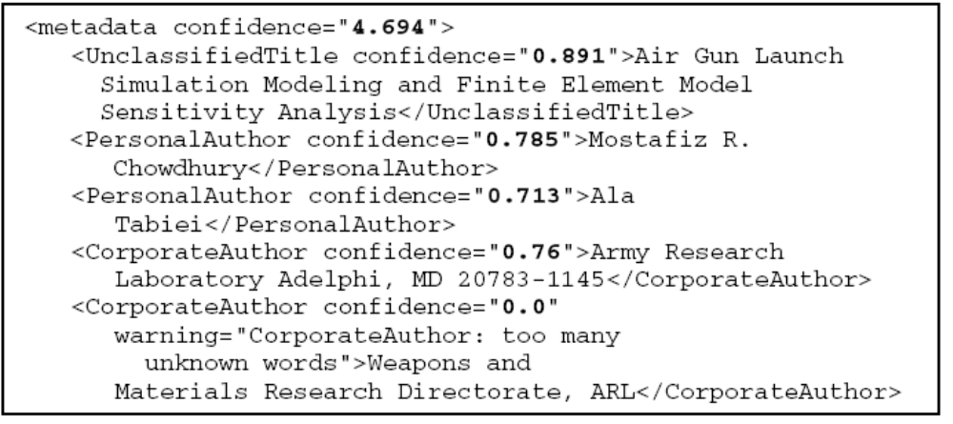
Fig. 5. Sample fragment of validator confidence values. In this example, we see that the second
CorporateAuthor gives a low confidence score because of the existence of too many words not
in the CorporateAuthor dictionary [1].

Output Processing. Referring back to the architecture diagram in Figure 1, the extracted metadata from both form and non-form processes enter output processing for postprocessing cleanup and validation.
Post-processing. The post-processing step is designed to compensate for the inherent uncertainties involved in the OCR recognition and extraction process. A modularized post-processing system was designed which can provide a variety of postprocessing functions for each metadata field.
Validation. The final step in this process is the validation step. The primary purpose of this step is to determine whether or not to flag the extracted metadata for human review. This validation engine uses statistical models of previously extracted metadata in the collection along with dictionaries for names and specialized content to determine the norms for the collection. While the validator will use the same validation engine to assess individual field values, the same script used in the non-form post hoc classification system is not used [1].

Comparison Criteria

Validation
The non-form extraction process generates a candidate extraction solution from the templates available. The final automated step of the process is the validation module. Any document that fails to meet the validation criteria is flagged for human review and correction [1].

Assessment
In this approach no assessment was applied, therefore no knowledge test was conducted to assess the players’ learning outcomes.

Customization

As mentioned before, no accessibility was used to minimize the cost and effort needed for student with physical problems.

Automation
This section described the efforts to develop a toolset and process for automated metadata extraction from large, diverse, and evolving document collections. The suggested automated process enables many more documents to be available online than would otherwise have been possible due to time and cost constraints .The regular layout present in an RDP form makes it an attractive target for a template-based extraction process. In order to take advantage of the geometric relationships between fields in a form, an alternate version of related template language and extraction engine is created. The proposed template-based meta data extraction system is composed of commercial and public domain software in addition to components developed by a team[1].

- Content generation
In this approach no method is used for creating content.

Automation in e-learning, games, serious educational games

Different Instructional Approaches Adopted in Educational Games
In this section we conduct a preliminary investigation attempting to examine how educational games implement instructional strategies to promote the players’ deeper understanding. According to the criteria proposed to this study, five studies were selected from the Social Sciences Citation Index (SSCI) database for this review. Through the analysis, the instructional approaches reviewed consisted of prediction-observation-explanation (POE), self-explanation, and interactivity. In addition to description of each instructional strategy, limitations and possible remediation were discussed and proposed for future research [2].

Introduction
There is a growing trend on using educational games to promote and improve academic learning. According to the researcher, many educational games tend to support the practice of factual information. That is, the player are inclined to keep performing certain of actions (e. g. clicking on a button) until the score improve. The purpose of this study was to review research studies of educational games so as to investigate how the instructional strategies were implemented in the games for enhancing the players’ deeper understanding. This study also analyzed the limitations indicated in each study and proposed possible suggestions for future research [2].

Results and Discussion in Approaches

The prediction-observation-explanation (POE)
A prediction-observation-explanation model is a potential approach to increase learners’ conceptual change. In the study, the POE model was integrated into the game design to support the third-graders’s acquisition of light and shadow concepts. In each stage of the game (four stages in the game), the players have to answer a question as well as justify the option selected before playing. The results show that those who played the game integrating the POE model outperformed those who did not in terms of the scores of the immediate test.

Self-explanation
Self-explanation is a method that prompts students to generate their own explanation orally, in writing, or through replying to a multiple-choice question. The goal of the game requires each player to solve ten circuit-related problems within a specific time. Scores are added or deducted whenever the players provide an accurate or inaccurate response to the problem. The players of a self-explanation group need to select a reason from a list before responding to the problem. The results show that those who played the self-explanation game outperformed those who played the game without self-explanation design. Regarding the type of self-explanation, those who selected a reason from multiple options gained higher scores than those who typed a reason themselves.

Collaboration
A number of studies have indicated that students can benefit from cooperating with peers in a learning activity. Collaboration refers to a situation that two or more students work together on constructing knowledge and solving problems. In a game environment, collaboration enables players to guess and discuss about game moves, strategies, or arguments. In the study investigating the effects of cooperative learning on playing a computer games, the results show that the engagement of the students who worked in pairs did not decrease. Furthermore, they outperformed those who played individually in terms of the posttest scores.

Problem-Based Gaming (PBG)
Problem-Based Learning (PBL) is an ideal way to engage learners in cognitive processes so that they can build knowledge or develop skills to solve problems effectively. To compete with some groups, players should manage the material flows, read market reports, and come up strategies against their competitors. The results display that the students showed a positives attitude toward the PBG game. They felt themselves involved in learning by doing as well as generating reflective thinking during the game.

Guidance, reflection, and interactivity
A pedagogical agent (e.g. a talking head) refers to either static or animated anthropomorphic interfaces implemented in a multimedia context to serve different instructional purposes, such as offering feedback, prompting questions, or supporting interactions. The researchers conducted three experiments to investigate how students’ deep learning was enhanced in an agent-based multimedia game that integrates instructional methods: guidance (the agent explains why an answer is accurate), reflection (learners are prompted to explain why an answer is accurate), and interactivity (learners are asked to respond to a problem instead of receiving an answer from the agent). The results show that ether guidance or reflection was able to support students’ science learning in a game context. In addition, reflection also fostered retention and far transfer only when the students were encouraged to reflect on the correct solutions provided by the agent (interactivity). That is, if asked to reflect on their own solutions, the students might not benefit from playing the game.

Summarized Results
The analysis revealed that all the five studies identified a positive impact of educational games on improving the students’ learning outcomes. Table 1 displays the summarized results of the five studies. As shown, most games conducted a knowledge test to assess the players’ learning outcomes [2].

Table 1: The summarized results of the studies reviewed [2]
Author(s) | Pedagogy | Limitation or Suggestion
Hsu et al. (in press) | Predict-observe-explain (POE) | - The design of narration might impose cognitive load on the preschoolers.  - The participants’ prior knowledge was not examined before playing the game.
Johnson & Mayer (2010) | Self-explanation | - The game context is too simple to match the complexity of computer games.  - It is suggested to provide feedback or scaffolding to help the player generate self-explanation.
Kiili (2007) | Problem-based gaming | - Rigorous efforts on developing a game fulfilling the complexity.  - Should support multiplayer connection.  - Cognitive overload for those without sufficient domain knowledge.
Moreno & Mayer (2005) | Guidance, reflection & interactivity | The study was limited to one type of interactivity, guidance and reflection. Future studies can design various types of strategies and examine the effects on improving learning outcomes.
Van Der Meij et al. (in press) | Cooperation | - The game might be unable to Support Sufficient depth of the dialogues.  - It is suggested to allow the players to another the gameplay after being tested to see if their learning outcomes are promoted.  - Test feedback can be designed by having the players debrief about the essential game features.

Comparison Criteria

Validation

No validation module has been implemented in this approach.

Assessment
In mentioned approached, most games conducted a knowledge test to assess the players’ learning outcomes. For example for POE, the participants’ prior knowledge was not examined before playing the game in POE. In Self-explanation, it is suggested to provide feedback or scaffolding to help the player generate self-explanation and test feedback can be designed by having the players debrief about the essential game features for collaboration game [2].

Customization

As mentioned before, no accessibility was used to minimize the cost and effort needed for student with physical problems.

Automation
In this approach no automation method was available due to time and cost constraints.

- Content generation
In this approach no method is used for creating content.

Game Development in Education Automatic and Semiautomatic Methodologies

Introduction

In this paper we discuss the need for tools that assist educators and educational content providers in producing games that are equally accessible for all. The goal is to minimize the cost and effort needed for introducing accessibility in serious games. We discuss to what extent the process of making a serious game accessible can be automated and supported by software tools that minimize human intervention. We conclude that there is a set of common accessibility barriers, especially those related to interaction and physical disabilities that can be addressed systematically in a high proportion and therefore could be dealt with by software.

Fully Automatic Adaptation of Interfaces - The case of 1492
In this work two user profiles were considered: blind users and users with a motor disability. Among the wide variety of levels of visual impairments, we characterized the blind user profile as users that needed the aid of screen reading software to use a computer. We considered users with a motor disability as those needed of using voice recognition software to interact with a computer due to reduced or lack of mobility. Both user profiles encounter barriers when interacting with point-and-click applications as they are not able to use the mouse.
The game author was only allowed to enable or disable the modules during the exportation process. All the adaptation to the user profile was performed automatically by analyzing the game description XML files and art resources (see Fig. 1).
The results were two new modalities which had common inner workings. The interaction was performed through short commands formulated in natural language (e.g. "grab the notebook" or "talk to the character"). An interpreter received the commands, executed them if they were correct, and provided feedback about the results using the appropriate channel for the active user profile (auditory for the blind user through a built-in text-to-speech engine, text for the user with a motor disability). Blind users introduced the commands using the keyboard, while users with a motor disability used speech [3].

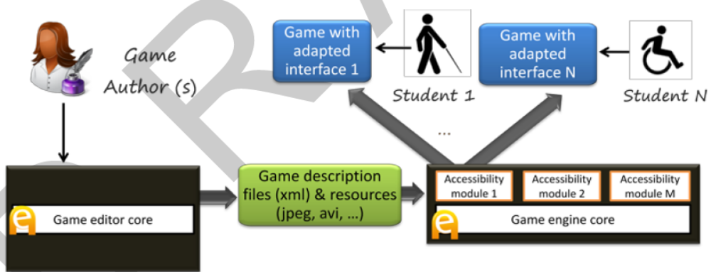
Fig 1. Basic accessibility architecture. Accessibility was provided by specific input/output modules integrated with the engine, which are activated when the game was exported [3].
Command processing was directed by a regular grammar combined with a fixed list of synonyms for relevant verbs (actions) and nouns (interactive elements). The regular grammar was automatically generated from the description of the game, taking the actions defined for the interactive elements available in each game scenario.

Semiautomatic Adaptation - The case of "My first day at work"
Another experiment which was resulted in the game "My first day at work", developed in collaboration with Technosite, a company of the ONCE (National Organization for the Blind in Spain) group. In Fig. 2, flexibility of the accessibility features was improved that now could be configured with the game editor [3].

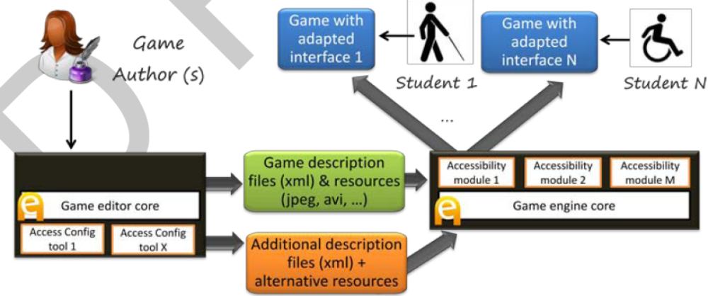 Fig. 2. Improved architecture and workflow. The accessibility features are now configurable from the editor to match different user profiles. The editor also produces automatically additional description files and resources [3].
In addition to the blind and motor disability profiles, a new user profile was considered: users with low vision. Colleagues from Technosite identified the adaptations this profile needed, which included screen and text magnification and use of a high contrast color scheme.
"My first day at work" was focused on meeting the needs of the three be-spoken profiles (blind, motor disability and low vision), it has been tried to make it accessible to users with cognitive disabilities (e.g. Down and Asperger syndromes).
Dealing with these problems is much more complicated and there is little room for automation. The eAdventure adaptation engine was used to provide alternative paths in the game with different levels of difficulty, or alternative versions of text intensive components such as conversations [3].

Level of automatic and semi-automatic adaptation
Table 1 shows a summary of the adaptations performed. Adaptations related to the modality, how the user interacts with the game or perceives the game feedback are prone to be automated (e.g. interfaces for blind users and users with reduced mobility).
Table 1. Summary of adaptations performed for each profile. Table reflects what aspect of the game were affected and the level of automation achieved[3].
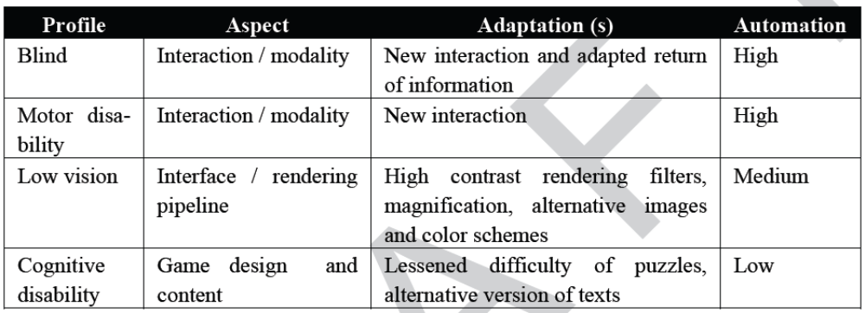

To make it accessible for users with low vision it was needed to produce alternative versions of 53 art resources, an increase of 7,57%. Although this value is not very high it could increase exponentially if more profiles were considered (e.g. users with color blindness), so it is important to keep the number of manually crafted alternative resources as low as possible [3].

Comparison Criteria

Validation
No validation module has been implemented in this approach.

Assessment
In this approach no assessment was applied, therefore no knowledge test was conducted to assess the players’ learning outcomes.

Customization

The goal is to minimize the cost and effort needed for introducing accessibility in serious games. In accessibility architecture. Accessibility was provided by specific input/output modules integrated with the engine, which are activated when the game was exported [3].

Automation
In the case of 1994, all the adaptation to the user profile was performed automatically by analyzing the game description XML files and art resources. The regular grammar was automatically generated from the description of the game, taking the actions defined for the interactive elements available in each game scenario.
In the case of "My first day at work”, the accessibility features are now configurable from the editor to match different user profiles. The editor also produces automatically additional description files and resources[3]. ( refer to table)

- Content generation
In this approach no method is used for creating content.

Automating e-Learning: The Higher Education Revolution

Introduction

5th Generation Distance Education: The Emerging e-University
The fifth generation distance education (The Intelligent Flexible Learning Model) will not be presented solely as a set of abstract principles, but will be illustrated within the context of the e-University Project.
The Award, presented by the Prime Minister at Parliament House in Canberra, focused on the preparation of graduates of both undergraduate and postgraduate courses and the university as a whole for the emerging ‘e-world’: http://www.usq.edu.au/GUG2000.htm The e-University Project was conceptualized in terms of three fundamental foci: the e-Information repositories, a variety of e-Applications and the e-Interface respectively. A graphic overview of University of Southern Queensland (USQ)’s e-University Project is presented in Figure 1.

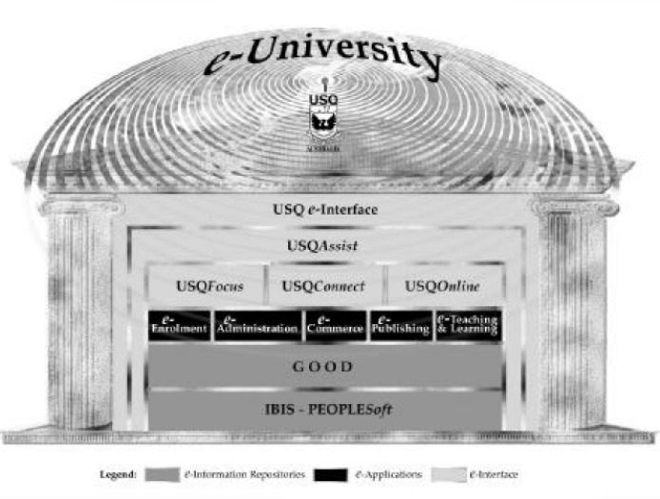
Fig. 1: Overview of USQ’s e-University Project.[4]

Learner Relationship Management
The USQAssist initiative is deploying tracking and automation tools to manage the interaction between the University and both its existing and prospective students. The most efficient, cost–effective way to manage the 24 x 7 challenge is to deploy effective automation tools, as opposed to running three shift student service desks or employing online tutors in different continents.
The deployment of e-Customer Relationship Management (e-CRM) software as “Learner Relationship Management” will ultimately enable the use of a single toll free number integrated with an email–based enquiry tracking system that will exploit the fundamental strengths of the Internet in enhancing communication and managing information. The USQ e-interface is being developed through the application of a web services approach. The implementation of the approach has entailed the creation of an Internet Systems Design, Development and Integration Team, and an Online Systems Technical Management Committee (OSTMC).
The OSTMC also provides a useful forum to support the implementation of USQ’s on campus wireless networking initiative http://www.usq.edu.au/its/wireless.

Automating e-Learning
In the USQ approach, many teaching staff make use of discussion groups, which entail students posting “reflections” via the asynchronous computer mediated communication (CMC) system. The teaching staff also post comments.
In the same vein, members of the teaching staff respond to student questions posted to the discussion group. Further, our experience demonstrates that other students often comment on the issues raised thereby enriching the depth and quality of the dialogue. The value of these contributions is particularly useful where students are giving examples of applications in different cultural contexts. While such fears can be allayed by the use of “one-to many” communication systems such as bulletin boards, mailing lists and threaded discussions, the underlying resource model is not significantly different from conventional on campus teaching, with a staff member being necessary to manage groups of approximately 20 students to maintain a reasonable quality of interaction and academic support. In contrast, the fifth generation Intelligent Flexible Learning Model has the potential to deliver major economies of scale in managing teaching and academic support through the exploitation of automated response systems (Fig 3)[4].
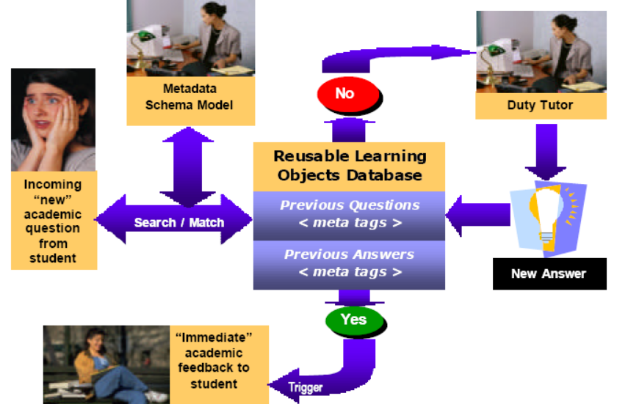
Fig. 3: Schematic representation of USQ’s 5th Generation Academic Productivity Enhancement System[4]

Upon receipt of an electronic query from a student, the staff member references the incoming question to a metadata schema model which has been devised for the course in question; the search engine then seeks an appropriate match with a previously asked question, which if successful, triggers a potential range of answers to the current question without further human intervention.
At this stage of development, the design of the system entails a tutor checking the validity of the match between the current question and the answers generated from the database before forwarding to the students with a single click of the mouse. Such a quality control mechanism may become redundant in the future. If no appropriate match is discovered in the database of previously answered questions, the query is automatically routed to the relevant tutor for an appropriate response, which is then added to the database with a single point and click.
Depending on the pedagogical design of the course, these responses can be directed to the whole cohort of students, to groups of students, or to individuals. The system has the advantage of providing more-or-less immediate pedagogical advice to students, a significant increase in institutional responsiveness, at minimal variable cost. It is worth noting that this system is not just aimed at reducing costs, USQ has a research program producing empirical evidence aimed at to validating the potential pedagogical efficacy of the approach, as illustrated by the following brief discussion of underlying instructional design theory and an associated exemplary investigation[4].

Comparison Criteria

Validation

No validation module has been implemented in this approach.

Assessment
In this approach no assessment was applied, therefore no knowledge test was conducted to assess the players’ learning outcomes.

Customization

As mentioned before, no accessibility was used to minimize the cost and effort needed for student with physical problems.

Automation
The USQAssist initiative is deploying tracking and automation tools to manage the interaction between the University and both its existing and prospective students. The design of the system entails a tutor checking the validity of the match between the current question and the answers generated from the database[4].

- Content generation
In this approach no method is used for creating content.

An Offline Planning Approach to Game Plotline Adaptation

Introduction
Role-playing games, and other types of contemporary video games, usually contain a main storyline consisting of several causally related quests. As players have different motivations, tastes and preferences, it can be beneficial to customize game plotlines. In this paper, we present an offline algorithm for adapting human-authored game plotlines for computer role-playing games to suit the unique needs of individual players, thereby customizing gaming experiences and enhancing re-playability. On-demand entertainment refers to the possibility that one can, at any time, request an entertainment experience that is significantly different from those previously consumed. In addition, entertainment artifacts should be customized or configured to suit every player’s unique motivation, tastes, history and ability. This paper addresses on-demand and customized entertainment in the context of generating plotlines for role-playing games.
The contribution of this paper is a system that solves the plotline adaptation problem: Given a complete, human-authored plotline consisting of sequence of quests, a library of quest structures, and a set of requirements about what an optimal gameplay experience should be for a particular user at a particular time, produce a sound, coherent variation that meets the requirements while retaining as much of the original plotline as possible. Offline processing affords the possibility to making globally optimal decisions about plotline structures, complimenting online adaptation techniques known as interactive storytelling. The supposed technique is justified with a discussion on theoretical authoring gains and empirical evaluation of our algorithm[5].

The Architecture of the Proposed System

Game Plot Adaptation
Figure 1 shows the adaptation pipeline for game plotlines. The game adaptation process takes a main plotline, a library of quest structures, and a set of player requirements as input. There may be more than one human-authored plotline, of which one is provided as input into our system. A player model generates a set of requirements, based on the player’s preferences, history, and a model of novelty. Importantly, the cycle between player and adaptation implies that games can be changed after each time it is played, thereby increasing its replayability. Possible actions in the virtual world are known to the system.

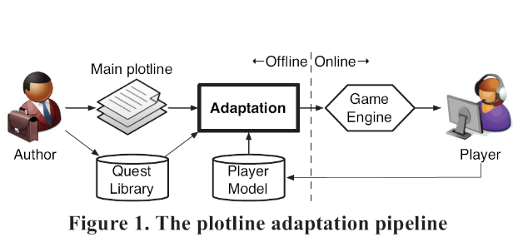

Plot Representation
Following others, the plan-like representations of narrative are employed because they capture causality and temporality of action and provide a formal framework built on first principles, such as soundness and coherence, for selecting and ordering events. However, unlike a plan meant for execution, we use plans as descriptions of events expected to unfold in a virtual world. Each action represents a formal declaration of an event that can be performed by the player or non-player characters, or occur as a consequence of physics laws in the virtual world.

The specific representation builds on partial-order plans. In this system, quests are represented as top-level abstract events. A quest has a single effect, guest complete (guest-X), and may or may not have any preconditions. Figure 2 shows a complete plotline consisting of two quests. Primitive actions are shown as solid rectangles and abstract actions are shown as rounded rectangles. The hierarchical relationship between events is reflected in the containment relationships of rectangles.
A coherent narrative is one in which, in the DAG formed by events and causal links, there is a path from each event to a significant outcome. Any event that is not part of some path to the outcome situation is referred to as a dead end[5].

Player Model
We model the player's preference as a function of previously selected quests. Each quest, in turn, is represented as a feature vector in a semantic space. We utilize a technique similar to that in Sharma et al. (2010) to determine preferences over quests via ratings after gameplay concludes; similarity metrics allow us to extend preferences to quests not previously experienced by the user. In addition, a novelty model based on (Saunders and Gero 2004) favors quests that are appropriately novel to the player based on his or her history so that he or she would be neither bored nor unpleasantly surprised. Computing a weighted sum of utility by preference and utility by novelty, the result is the selection of the k quests with the greatest utility that should be included in the game plotline. Due to space constraints, a detailed description is beyond the scope of this paper.
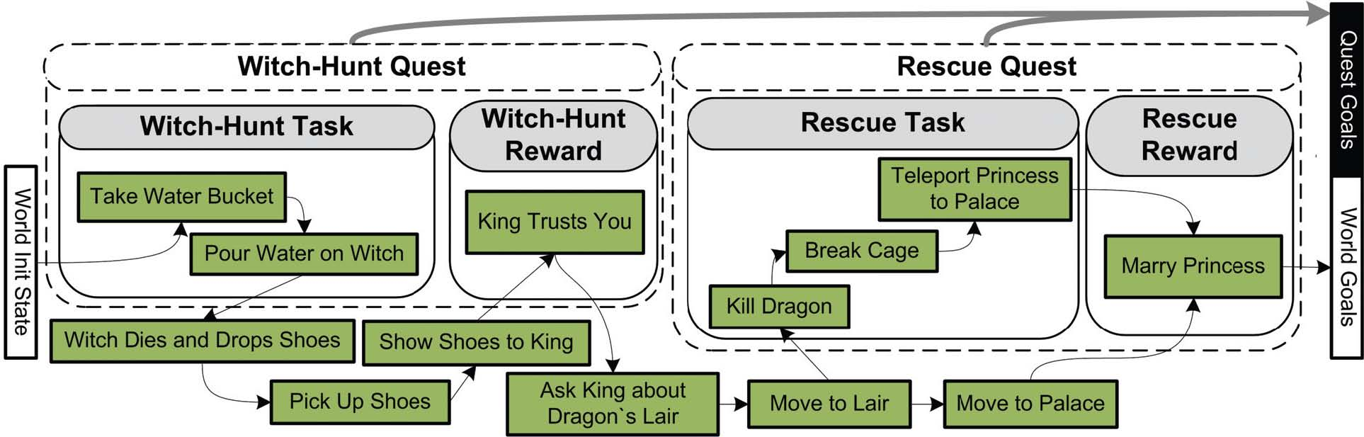
Figure 2. Original game plotline before adaptation[5]

Adaptation Algorithm

The plot adaptation module receives as input the following components:

- A complete plotline – a partially ordered, hierarchical plan – composed of events within and outside of quests.
- A set of plot requirements: guest complete (guest-X) propositions specifying what quests should be included, and corresponding world-level outcome propositions.

Our adaptation algorithm is shown in Figure 3. The main loop is the standard plan refinement search loop. In addition to the pre-processing stage, we implement the following flaw types:

- Open condition: an event has a precondition not satisfied by any causal links from a temporally earlier event or the initial state.
- Causal threat: An event has an effect that undoes a condition necessary for another event to occur and there are no ordering constraints forbidding the interaction.
- Un-decomposed event: An abstract event has not been decomposed.
- Dead end: An event is not on a causal path to the outcome state.

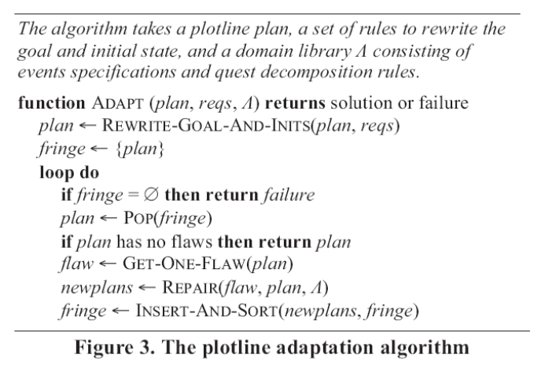

Each flaw type is paired with one or more repair strategies. Repair strategies can be additive or subtractive. Additive strategies are as follows. An open condition flaw can be repaired by instantiating a new event with an effect that unifies with the open precondition or by extending a causal link from an existing event to the open precondition. Thus events are added to a plan in a backward-chaining fashion. A causal threat can be repaired by imposing ordering constraints between events. An un-decomposed event can be repaired by selecting and applying a decomposition rule, resulting in new events instantiated, or existing events reused, as less abstract children of the abstract event .Dead-end flaws can be handled in an additive fashion.
Authoring
Plotline adaptation scales up the ability to deliver customized experiences without significantly increasing the authoring effort. We focus on variability – the number of distinct stories – as our metric.
A one-time authoring cost by a domain engineer is incurred in the development of a world domain model, containing specifications for primitive events, abstract events (including quests), and decomposition rules. The payoff is a theoretically exponential leverage. The adaptation process can theoretically produce as many variations of a given plotline as the size of the power set of available quests. Thus, one strength of plotline adaptation is the ability to opportunistically discover new transitions between quests based on the world model. Future work is required to measure the pragmatic authorial leverage of the system[5].

Conclusions
As game players possess different motivations, tastes and needs, a one-size-fits-all approach to game plotlines may prove to be limiting. We treat adaptation as the optimization of plotlines based on requirements derived from a player model employing knowledge about player preferences and a model of novelty. As such, we find an offline approach to be beneficial in achieving global optimization of plotline structure.
The adaptation problem itself is solved by an iterative improvement search based on partial order planning. However, in order to start from a complete plotline and arrive at a variation with different quests, we employ both additive and subtractive improvement mechanisms. To the extent that the player model is an approximation of player preferences, future work may pair our offline adaptation technique with online interactive storytelling engines.
As the world orients toward greater on-demand and customized entertainment experiences, overcoming the content authoring bottleneck will increasingly require automation on the level of creative production. We believe that a partnership between human authors and automated adaptation can scale up our ability to deliver the “right story to the right person at the right time.”

Comparison Criteria

Validation

No validation module has been implemented in this approach.

Assessment
In this approach no assessment was applied, therefore no knowledge test was conducted to assess the players’ learning outcomes.

Customization
In this section, an offline algorithm was presented for adapting human-authored game plotlines for computer role-playing games to suit the unique needs of individual players, thereby customizing gaming experiences and enhancing re-playability.

Automation
In this approach no automation method was available due to time and cost constraints.

- Content Generation
In this paper, we explore the use of automated content generation as a means of scaling up the delivery of on-demand, customized entertainment content. In the realm of automated content generation, plotlines may be generated from scratch [5].

Table of Comparison Criteria

As it was mentioned before, five approaches were compared to each other through 5 comparison criteria, which are shown in below table:

CC  Approaches | Validation | Assessment | Customization | Automation | Content Generation
Automated Template-Based Metadata Extraction
Instructional Approaches Adopted in Educational Games
Game Development in Education Automatic and Semiautomatic Methodologies
Automating e-Learning: The Higher Education Revolution

An Offline Planning Approach to Game Plotline Adaptation

Conclusions and Future Work

subheading
xxx

subheading
xxx

subheading
xxx

subheading
xxx

subheading
xxx

subheading
xxx

References
// use correct format for book, journal, conference paper
// avoid websites
.. sort either a)alphabetical by first author’s last name or b) order of appearance in the article
- Paul Flynn, Li Zhou, Kurt Maly, Steven Zeil, and Mohammad Zubair, Automated Template-Based Metadata Extraction Architecture, ICADL 2007, LNCS 4822, pp. 327–336, Springer-Verlag Berlin Heidelberg 2007.

- Javier Torrente, Ángel del Blanco, Ángel Serrano-Laguna, José Ángel Vallejo-Pinto, Pablo Moreno-Ger, Baltasar Fernández-Manjón, Towards Universal Game Development in Education Automatic and Semiautomatic Methodologies, Springer-Verlag Berlin Heidelberg 2011.
- Automating e-Learning:
- The Higher Education Revolution

- Javier Torrente, Ángel del Blanco, Ángel Serrano-Laguna, José Ángel Vallejo-Pinto, Pablo Moreno-Ger, Baltasar Fernández-Manjón

- Javier Torrente, Ángel del Blanco, Ángel Serrano-Laguna, José Ángel Vallejo-Pinto, Pablo Moreno-Ger, Baltasar Fernández-Manjón

- Javier Torrente, Ángel del Blanco, Ángel Serrano-Laguna, José Ángel Vallejo-Pinto, Pablo Moreno-Ger, Baltasar Fernández-Manjón
S. Tang, Javier Torrente, Ángel del Blanco, Ángel Serrano-Laguna, José Ángel Vallejo-Pinto, Pablo Moreno-Ger, Baltasar Fernández-Manjón
M. Hanneghan, Javier Torrente, Ángel del Blanco, Ángel Serrano-Laguna, José Ángel Vallejo-Pinto, Pablo Moreno-Ger, Baltasar Fernández-Manjón
- A Model-Driven Framework to Support Development of Serious Games for Game-based Learning, School of Computing and Mathematical Sciences, Liverpool John Moores University, UNITED KINGDOM, 2010 Developments in E-systems Engineering, IEEE Computer Society, 2010 .
- Cheng-ping Chen, Ju-ling Shih, A Prototype on a Meta-model for Designing Instructional Pervasive Games, Department of Information and Learning Technology, National University of Tainan, 2012 Fourth IEEE International Conference On Digital Game And Intelligent Toy Enhanced Learning, 2012.
- Sara de Freitas, Learning in Immersive Worlds: A review of game-based learning, Prepared for the JISC e-Learning Programme.

¹Department of Software Engineering and Artificial Intelligence, Complutense University of Madrid.
C/ Profesor José García Santesmases sn, 28040 Madrid (Spain)

Previous:

- C. Shaun Longstreet, Kendra Cooper, A Meta-model for Developing Simulation Games in Higher Education and Professional Development Training, IEEE 17th International Conference on Computer Games, Kentucky, USA ,2012
- S. Tang, M. Hanneghan, A Model-Driven Framework to Support Development of Serious Games for Game-based Learning, School of Computing and Mathematical Sciences, Liverpool John Moores University, UNITED KINGDOM, 2010 Developments in E-systems Engineering, IEEE Computer Society, 2010 .
- Cheng-ping Chen, Ju-ling Shih, A Prototype on a Meta-model for Designing Instructional Pervasive Games, Department of Information and Learning Technology, National University of Tainan, 2012 Fourth IEEE International Conference On Digital Game And Intelligent Toy Enhanced Learning, 2012.
- Sara de Freitas, Learning in Immersive Worlds: A review of game-based learning, Prepared for the JISC e-Learning Programme.
- Jeannette Bennett, Kendra Cooper, Lirong Dai, Aspect-oriented model-driven skeleton code generation: A graph-based transformation approach, Science of Computer Programming 75, pp: 689_725, 2010.
- Antti Kirjavainen, Development of Game-Based Learning Environments – Constructing a Quality Multi-Disciplinary Development Process, University of Jyvaskyla, Department of Mathematical Information Technology & Agora Center, Dissertation in Information Technology, October 6, 2009.
- Masoud Hemmasi, Lee A. Graf, Illinois State University, EDUCATIONAL EFFECTIVENESS OF BUSINESS SIMULATION GAMING:A COMPARATIVE STUDY OF STUDENT AND PRACTITIONER PERSPECTIVES, Development In Business Simulation & Experiential Exercises, Volume 18, 1991.
- S. Tang, M. Hanneghan, Fusing Games Technology and Pedagogy for Games-Based Learning Through a Model Driven Approach, School of Computing and Mathematical Sciences, Liverpool John Moores University, Liverpool, UNITED KINGDOM, 2011 IEEE Colloquium on Humanities, Science and Engineering Research (CHUSER 2011), Dec 5-6, Penang, 2011.
- Nathan Balasubramanian,Brent G. Wilson, GAMES AND SIMULATIONS, Society for Information Technology and Teacher Education (SITE), 2005.
- Tsung-Li Wang, Ya Fen Tseng, Learning Effect for Students with Game-based Learning on Meta-Analysis, The 6th International Conference on Computer Science & Education (ICCSE 2011), pp. 1291-1295, August 3-5, 2011. SuperStar Virgo, Singapore, 2011.
- Javier Torrente, Pablo Moreno-Ger, Baltasar Fernández-Manjón (2008). Learning Models for the Integration of Adaptive Educational Games in Virtual Learning Environments. Proceedings of the 3rd International Conference on E-learning and Games (Edutainment 2008), Nanjing, China. Lecture Notes in Computer Science 5093, pp. 463–474.
- Miroslav Minović, Miloš Milovanović, Mladjan Jovanović, Dušan Starčević, Model Driven Development of User Interfaces for Educational Game, HSI 2009 Catania, Italy, May 21-23, 2009
- Lina Marcela Morales, David Mendez-Acuna, Willy Montes, Model Driven Game Development - Case Study A MTC for maze game prototyping Departamento de Ingeniera de Sistemas y Computacion, Universidad de los Andes, Colombia.
- Marcio de O. Barros, Alexandre R. Dantas, Gustavo O. Veronese, Claudia M. L.Werner, Model-driven Game Development: Experience and Model Enhancements in Software Project Management Education, Softw. Process Improve. Pract. pp. 411–421. 2006.
- Miroslav Minovic, Milos Milovanovic, Dusan Starcevic, Modelling Knowledge and Game Based Learning: Model Driven Approach, Journal of Universal Computer Science, vol. 17, no. 9 pp. 1241-1260. 2011.
- Diana Oblinger, Simulations, Games, and Learning, EDUCAUSE, May 2006.
- STEPHEN TANG, Martin Hanneghan, State of the Art Model Driven Game Development: A Survey of Technological Solutions for Game-Based Learning, Journal of Interactive Learning Research (201 1) 22(4), pp: 551 -606.
- Josephine M. Randel, Barbara A. Morris, C. Douglas Wetzel and Betty V.Whitehill, The Effectiveness of Games for Educational Purposes: A Review of Recent Research, Simulation & Gaming, 1991.
- Kendra Cooper, C. Shaun Longstreet, Towards Model-driven Game Engineering for Serious Educational Games: Tailored Use Cases for Game Requirements, IEEE 17th International Conference on Computer Games, Kentucky, USA ,2012.

Appendix A. title here

